U.S. Government Name:
Mrs. Barnes
Public Opinion and the Media

What Is Public Opinion and How Is It Shaped?
Public opinion is how the public feels/thinks about a person or issue. We can figure out public opinion by asking people what they think and adding up their responses. But, how do people come up with their opinions?

- Public opinion is shaped by special interest groups.
People listen to what interest groups have to say (for instance, the NRA thinks that gun ownership should be protected.
- Public opinion is shaped by journalists, politicians, and other opinion makers.
People get information and advice by watching the news, or reading about politics.
- Public opinion is shaped by what politicians say it is.
Politicians can influence what people say (for instance, Donald Trump and Bernie Sanders are
Influential because they tell people what they think).

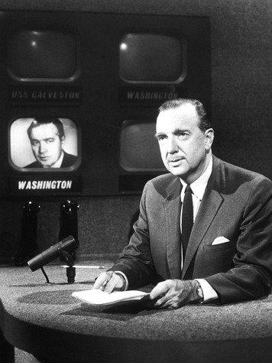
Why is Public Opinion Important?
Public opinion is important because it helps leaders make decisions. Politicians (like the President, and other representatives) listen to what the people have to say and then pass laws based on what the people think.

The Impact of the Mass Media on Public Opinion
Media helps us to communicate. Examples of media would be newspapers, magazines, websites, television, radio, social media, etc. What we see or read in the media helps us to develop opinions.

Where Do Americans Get Their News?
Americans used to get their news from the print media—mainly newspapers and magazines. By the 1950s, the broadcast media—mainly radio and television—had become major sources of news. Now we have 24-hour news programming available on both radio and cable television stations. People today also turn to electronic media—computers, cell phones, and other communication devices that connect via the Internet to the World Wide Web.

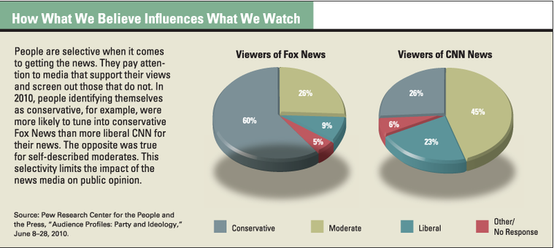
Candidates today are reaching voters through Facebook and Twitter, YouTube, and Saturday Night Live. Blogs have also become a popular way of getting and distributing information. While blogs are often written by specialists, in many cases these writers are not accredited. Some of what passes for news on blogs may be gossip, false rumor, or opinion. Because bloggers are not required to follow the same standards for accuracy as professional journalists, their reports should be read with caution.
Source: TCI Government Alive!
Follow Up Questions:

- What is public opinion?

- What are the three ways public opinion is shaped?

  - ______________________________________________________________________________________

  - ______________________________________________________________________________________

  - ______________________________________________________________________________________

- Why is public opinion important?

- Define:
  - Print Media: ________________________________________________________________________

  - Broadcast Media: __________________________________________________________________

  - Electronic Media: ___________________________________________________________________

- Other than newspapers and television, what are two ways candidates can communicate with the people?

  - ______________________________________________________________________________________

  - ______________________________________________________________________________________

