U.S. Government Name:
Mrs. Barnes
Political Parties

Political advertisements dominate our television screens during election season. They tell us who we should vote and why, and also who we should not vote for and why. Most people believe that political parties (organizations that seek to achieve power by electing its members to office) are responsible for these ads, but in reality most of these ads are created by and paid for by interest groups. Interest groups are any organized group whose members share a common goal and try to promote their interests by influencing government policymaking and decision making. Increasingly, interest groups have joined political parties as key players in the American political process. Both types of organizations are actively engaged in politics, providing information to officials and the public and seeking to affect the outcome of elections.

What Do Political Parties Do in a Democracy?
The primary goal of parties is to get their candidates elected to office. However, they also have a number of other functions, some of which are listed below.

Parties recruit candidates and support campaigns. Each year, political parties seek out and enlist candidates to run for thousands of local, state, and national offices. They look for people with the skills to run a successful electoral campaign and to be effective in office. Political parties also provide some funding for candidates.

Parties help organize elections and inform voters. Although state and local governments run elections, political parties help by promoting voter interest and participation. They register voters and monitor the polls on Election Day. They also help inform voters on political issues.

Parties organize the government. Congress and most state legislatures are organized along party lines. After congressional elections, members of the majority party in Congress choose one of their members to be speaker of the house or Senate majority leader. Committee chairpersons in Congress also come from the majority party.

Parties unite diverse interests and make collective action possible. Parties bring diverse groups together by building coalitions based on shared beliefs and common goals. Delegates attending national party conventions create platforms that outline the party’s position on important issues. In that process, they seek to balance the interests and concerns of members from across the country.

Parties serve as a loyal opposition to the political party in power. The goal of a political party is to win control of the government so that it can translate its objectives into laws and policies. The party not in power, or the minority, serves as a “loyal opposition” to the majority party. Minority party members act as critics of the majority party’s proposals, and act as “watchdogs,” always on the lookout for corruption or abuses of power.

Political parties also offer various ways for citizens to get involved in politics. The most common way is through voter registration. Most Americans identify with one party or the other, and they register to vote as a member of that party. Citizens can also donate money to a political party or its candidates, show their support using social media, and attend party rallies or meetings. In addition, some citizens volunteer to work on party committees or individual campaigns.

Today, there are two major political parties in the United States: Democrat and Republican. We refer to this as a “Two-Party System.” Over the years, the two major parties have evolved and changed and so have their support bases. For example, the Democrats were once the strongest part in the South and supported more state and local control. Today the Republicans generally enjoy more support in the South and sponsor more “states’ rights” issues.

In 2000, political analysts began to speak of a regional divide in American politics. The 2012 presidential election results also showed clearly defined “red states” and “blue states.” The red states—mainly in the southern and central parts of the country—were those in which the majority of people voted Republican. The blue states—mainly in the Northeast and far West—were those in which the majority voted Democratic. The distribution of red and blue states led many political observers to conclude that the United States had become deeply divided along political lines. “Purple states” are ones that have voted both Democrat and Republican in the last few elections and are therefore considered “swing” states.

Republicans and Democrats in the Twenty-first Century
While all kinds of Americans support either party, a Republican is more likely to be white, male, and relatively affluent. A Democrat is more likely to be a member of a minority group, female, and less affluent. This graph shows other differences between the Republicans and Democrats. In general, Republicans hold more conservative views, and Democrats more liberal views, on the issues that follow.

Size of the national government. In general, Democrats support a strong federal government and look to it to solve a wide variety of problems. Most Republicans favor limiting the size of the national government and giving more power to the states to solve problems at a local level.

Taxes. Republicans favor broad-based tax cuts to encourage economic growth and to allow people to keep what they earn. Although Democrats favor tax cuts for the poor, they are more willing to raise taxes on affluent Americans in order to support programs that they see as beneficial to society.

Regulation of business. Democrats generally support government regulation of business as a way to protect consumers, workers, or the environment. Most Republicans oppose what they see as excessive business regulation by the government believing that too much regulation prevents economic growth.

Social issues. Republicans tend to oppose legalizing same-sex marriage, abortion, and gun control laws. Democrats are more likely to support same-sex marriage rights, abortion, and gun control laws.

Environment. Most Democrats favor strict environmental regulations. Republicans tend to oppose such regulations because they believe it hurts businesses and the economy.

While these generalities hold for the two political parties, individual Democrats or Republicans may not share the same views on every issue. Some Republicans, for example, strongly support equal rights for gay and lesbian Americans. At the same time, many traditional Republicans are just as strongly opposed to granting certain rights, such as the right to marry, to gay and lesbian couples. Nevertheless, for most Americans, identifying with one party or the other provides a useful way to make sense of the candidates at election time.

Source: TCI Government Alive!

Follow Up Questions:
- Define political party.

- Define interest group.

- What is the primary goal of a political party? List three other activities that political parties “do in our democracy.”

- List the other ways political parties help citizens get involved in politics:

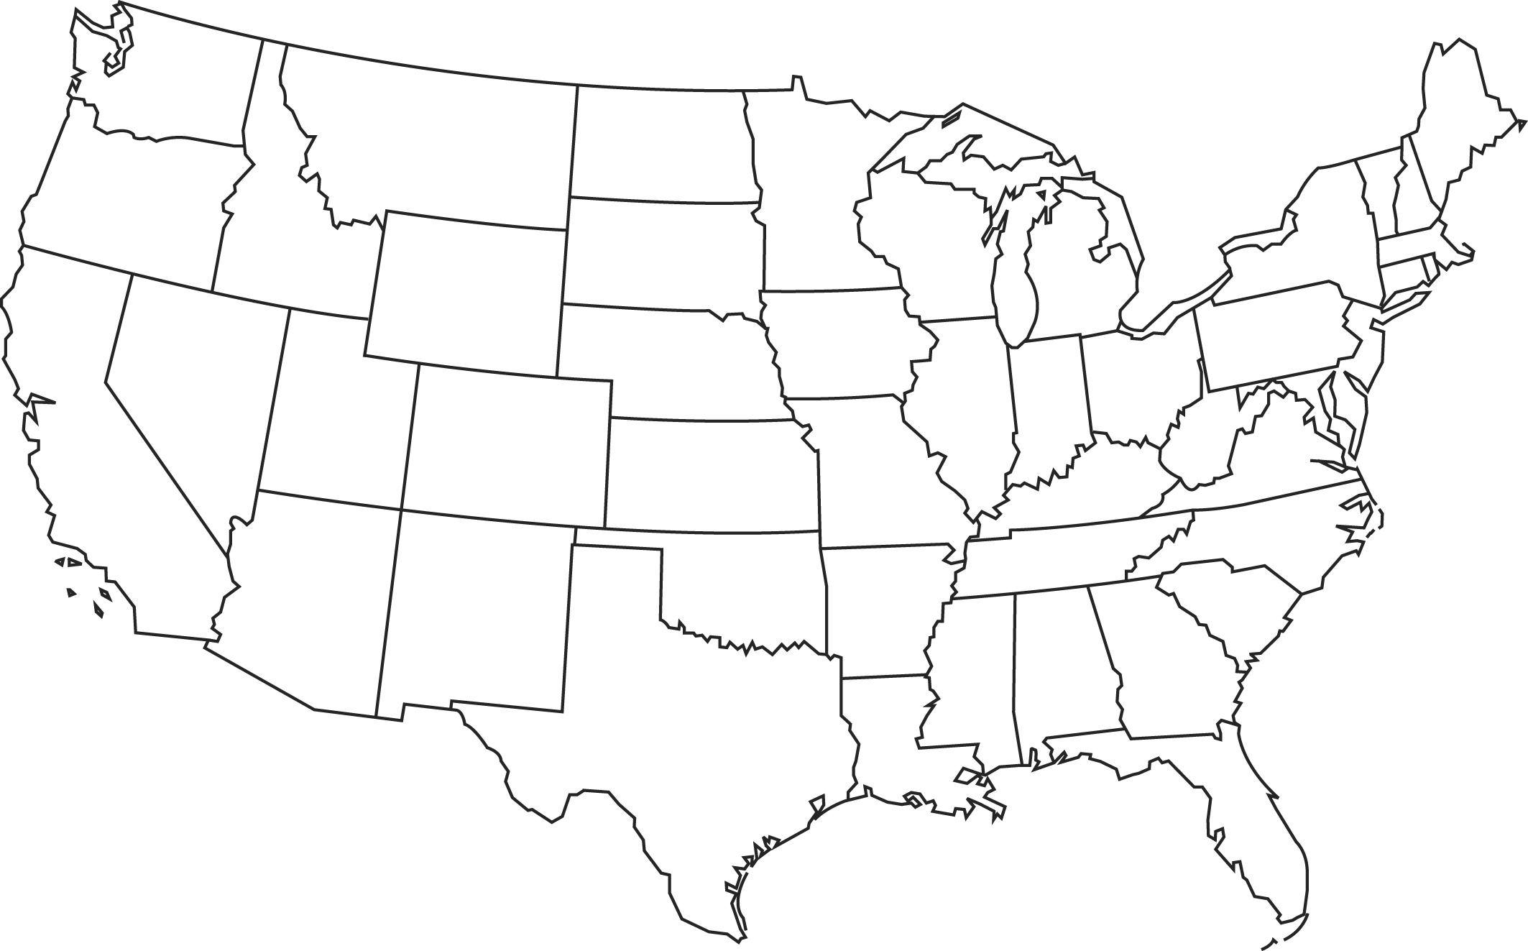
- Where are “red” states most likely to be found? Where are “blue” states likely to be found? Using a red circle and a blue circle, identify those regions on the map to the right:

What is a “purple state”?

- Identify the differences between Republicans and Democrats on the following major issues:
Issue | Democratic Stance | Republican Stance
Size of the National Government
Taxes
Regulation of Business
Social Issues
Environment

