U.S. Government Name:
Mrs. Barnes
Political Games
Politics is serious business. Decisions made by governments can have a profound impact on people’s health, wealth, and happiness. Yet politics is also a form of competition; think of it like a sport. Politicians (and citizens who engage in political activity) are all players in the “game of politics.” In order to win, you must have a game plan, and you must be able to execute. Below are the goals and strategies of five political “games” people play in order to win.

Horse Trading: Winning by Giving to Get
Horse trading is a classic American business. In the old days, traders brought their horses to a local market where interested buyers would look at them to determine their value. Horse traders bargained. The buyer and seller would go back and forth until they reached a price they both agreed on. Today, horse trading is another name for the kind of hard bargaining that goes on in politics. The key players are often politicians who want something that they cannot get without help from their political opponents. Often this “something” is a proposed law.

The objective of the horse-trading game is to achieve a “win-win situation,” in which both players walk away satisfied. The basic strategy involves giving up something one’s opponent wants in exchange for something of equal—or greater—value. The horse-trading game is familiar to many children and parents. A teenager, for example, might negotiate to stay out an hour beyond normal curfew on a Saturday night in exchange for a pledge to help clean out the garage the next day. In this game, each side has given up something to get something else it wants.

Walkout: Winning by Refusing to Play
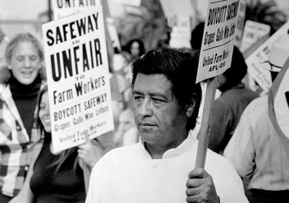
Whereas horse-trading gives something to the opponent, walkout takes something away—usually themselves. They walk out of the game and refuse to return until the opposition agrees to give them something they want. The classic example of this strategy occurs in a pickup basketball or football game when the owner of the ball gets upset, perhaps about a disputed rule or a foul. The offended player picks up the ball and threatens to go home. This puts pressure on the other players to give in. They know that without the ball, the game cannot continue. On a larger scale, the walkout game is commonly played by labor unions to back up demands for better pay and working conditions. If employers refuse those demands, union workers may choose to strike, or walk off their jobs. Without workers, businesses find it difficult to function. This puts pressure on the employer to come to terms with the union.

César Chávez successfully used walkout tactics in his struggle to improve the lives of California farm-workers. In 1962, Chávez, along with Dolores Huerta, founded the National Farm Workers Association, later to become the United Farm Workers. Their goal was to convince growers to treat their workers fairly, with dignity and respect. When growers refused to bargain with the new union, Chávez organized a strike of California grape pickers. In addition to the strike, he encouraged all Americans to boycott table grapes as a show of support. The strike and boycott lasted five years and brought national attention to the struggle of farmworkers for decent pay and working conditions. It also led to the first major labor victory for farmworkers in the United States.

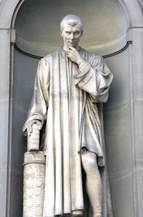
Power Struggle: Winning by Being Smarter and Stronger than the Opposition
Politics is often about power struggles between people with very different goals. When engaged in such a struggle, clever politicians try to win by outfoxing or overpowering their opponents. The strategies needed to win the power struggle game were first described by a 16th-century political philosopher named Niccolò Machiavelli. Machiavelli was born in Florence, Italy, and rose to a high position in the city’s government. He examined the behavior of leaders, good and bad. From this, he developed ideas about how best to win the power struggle game. In his most famous book, The Prince, Machiavelli described strategies that a prince, or ruler, could use to acquire power, create a strong state, and keep it safe from attack. To play the power struggle game, Machiavelli wrote, a ruler needed to be as smart as a fox and as strong as a lion. As a player in this game, a prince had to be prepared to do whatever was necessary for the survival of his state.

Demolition Derby: Winning by Wiping Out the Opposition
While the goal of the power struggle game is survival in a sea of enemies, the aim of demolition derby is the complete destruction of one’s opponents. The game takes its name from car-crashing contests in which drivers use their vehicles as weapons to demolish the other cars. The winner is the last car running at the end of the contest. In the political version of this game, players try to eliminate all real and perceived enemies.
The key players in demolition derby are those who command the means of force. They include military leaders, dictators, and monarchs. Players use a variety of strategies, ranging from fear and intimidation to murder and massacres, to wipe out the opposition.

The demolition derby game often ends in a bloodbath. In the Third Punic War, Rome’s army totally demolished Carthage, burning the city to the ground. The 50,000 Carthaginians who survived this destruction were sold into slavery. According to legend, the Romans then plowed salt into the ground surrounding Carthage so that nothing would ever grow there again.

Civil Disobedience: Winning by Shaming the Opposition
At the opposite end of the spectrum from demolition derby players are those who refuse to violence. The key players in the political game of civil disobedience are people of conscience, whose goal is to end some social or political evil. Their strategy involves publicly shaming the opposition, rather than using violence. They accomplish this by deliberately disobeying what they consider an unjust law.

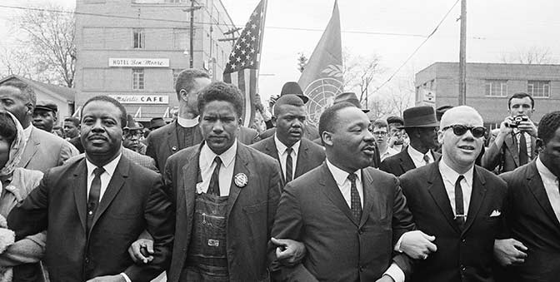
People who practice civil disobedience remain nonviolent and hope that people follow them because of their “high morals.” (think: Martin Luther King Jr.’s fight for civil rights and equality) Another famous instance of this was Mohandas Gandhi, a leader who wanted to free India from British control. He organized campaigns where people refused to work for the government and blocked streets so that nothing could move. He peacefully took action against the government to force change.

DIRECTIONS: After having read the above information, fill out the chart below. Write a one sentence description (or definition) of each “game,” then explain one example from the reading.

Game: | Description: | Example:
Horse Trading

Walkout

Power Struggle

Demolition Derby

Civil Disobedience

