U.S. Government Name:
Mrs. Barnes
From Ideas to Independence: The American Revolution
The American colonists gathered ideas about government from many sources and traditions. But these ideas did not all come from the study of ancient history or European philosophy. They were also shaped by the colonists’ everyday experiences of life in colonial America.

Colonial Experience with Self-Government
Most of the 13 colonies were established under royal charters issued by the king. These charters gave ultimate power to the king and his appointed officials. But because the colonies were so far away from Britain, the charters left a significant amount of local control in the hands of the colonists themselves. One example of an early agreement was the Mayflower Compact. This historic document acted as the legal code for the pilgrims who came on the Mayflower in 1620.
New England colonists soon developed their own form of local government, a version of direct democracy known as the town meeting. At these meetings, residents could discuss issues and make decisions that affected their community. As time went on, colonists began to write and follow their own sets of laws that guaranteed certain basic rights. By the early 1700s, most colonies had developed a governing structure of executive, legislative, and judicial branches (think: Montesquieu). The executive was a governor, usually appointed by the king. Royal governors had substantial power, although that power could be partly limited by colonial legislatures.
The legislatures typically consisted of two houses. In this case, the voters, only white, male landowners could exercise their power by voting. These assemblies reflected a belief in self-government and affirmed the principle that the colonists could not be taxed except by their elected representatives.

From “Benign Neglect” to Armed Rebellion
By the mid-1700s, the colonies were accustomed to managing their own affairs. Britain provided defense (military) and a market for products grown or produced in the colonies. But, Britain rarely interfered with the day-to-day business of government.
In the 1760s, however, Britain reversed this policy of “benign neglect” (also known as “salutary neglect”) by enforcing taxes and restrictions on the colonies. This change came about after the French and Indian War, a war fought against France and its Indian allies on North American soil.
Britain won the French and Indian War in 1763. As a result, it gained control of Canada and the Ohio Valley, areas formerly claimed by France. To defend that territory, Britain had to station more troops in the colonies. The British government argued that the colonies should pay some of the cost of this added defense. To achieve that end, Parliament enacted the Stamp Act in 1765, which said Americans must buy stamps to place on their deeds, mortgages, liquor licenses, playing cards, almanacs, and newspapers.
The colonists were outraged. In their eyes, the stamps were a form of taxation. As British citizens, only their elected representatives could tax them. Therefore, because the colonies had no representation in Parliament, the taxes were illegal. Raising the cry of “no taxation without representation,” the colonists united in protest against the Stamp Act. In response, the British government repealed the hated act. But it continued trying to control the colonies through taxes and other measures. Protests continued and violence flared. On March 5, 1770, British troops shot and killed five agitators in Boston, an incident known as the Boston Massacre.
In 1773, Parliament tried again to force the colonies to accept its authority, this time by placing a tax on imported tea. Late that year, three ships arrived in Boston Harbor with the first load of taxed tea. Colonists dressed as Indians emptied 342 chests of tea into the harbor in defiance of British authority.
In a belated effort to crack down on such protests, Parliament imposed sanctions known in the colonies as the Intolerable Acts. These harsh penalties further inflamed colonial resistance to British rule. Hoping to defuse the escalating conflict, colonial leaders gathered in Philadelphia in 1774. This assembly, called the First Continental Congress, called for peaceful opposition to British policies. By this time, however, colonial patriots were already forming militias, or groups of armed citizens, to defend their rights. On April 19, 1775, militia troops from Massachusetts clashed with British soldiers in battles at Lexington and Concord. These skirmishes marked the beginning of the American Revolution.

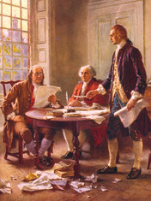
The Decision to Declare Independence
Shortly after fighting broke out in Massachusetts, the Continental Congress met again. The delegates quickly voted to form a Continental Army made up of volunteers from all the colonies. They chose George Washington, a leading officer in the Virginia militia, to be the new army’s commanding officer.
Still, the Congress hesitated to call for a final break with Britain. Many delegates hoped instead that a peaceful resolution could be found. John Adams of Massachusetts, however, was not among them. Over the next year, Adams worked tirelessly to convince his fellow delegates that independence should be their goal.
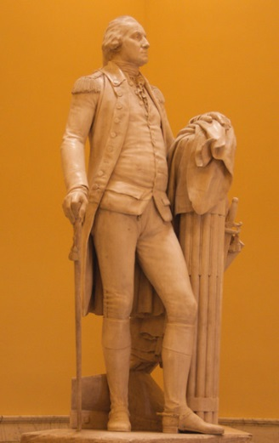
Finally, in June 1776, the Congress formed a committee to draft a declaration of independence. This committee consisted of five men: Thomas Jefferson of Virginia, John Adams of Massachusetts, Benjamin Franklin of Pennsylvania, Roger Sherman of Connecticut, and Robert R. Livingston of New York. The task of crafting the first draft went to Jefferson. A gifted writer steeped in Enlightenment ideas, Jefferson wrote,
We hold these truths to be self-evident, that all men are created equal, that they are endowed by their Creator with certain unalienable Rights, that among these are Life, Liberty and the pursuit of Happiness.—That to secure these rights, Governments are instituted among Men, deriving their just powers from the consent of the governed.
—Declaration of Independence, 1776
In these two sentences, Jefferson set forth a vision of a new kind of nation. Unlike old nations based on blood ties or conquest, this new nation was born of two key ideas. The first is that governments are formed to protect people’s unalienable rights. In a slight twist on Locke, Jefferson defined those basic individual rights as the rights to life, liberty, and the pursuit of happiness. The second key idea is that governments derive “their just powers from the consent of the governed.” The Declaration goes on to say that if a government fails to protect people’s rights, the people should abolish it and form a new one. To bolster the case for doing just that, the Declaration details “a long train of abuses” that violated the colonists’ rights. The document concludes with the bold declaration that
On July 4, 1776, the members of Congress formally approved the Declaration of Independence. The Declaration was later written on parchment for delegates to sign. By signing the Declaration, the delegates were making a formal declaration of war against what was then the most powerful nation on Earth.
Source: TCI Government Alive!

