U.S. Government Name:
Mrs. Barnes
Political Culture and Ideology

Although Americans share a common political culture, they do not all hold to the same ideology, or basic political beliefs. For example, they often disagree on the role government should play with respect to economic policy and moral values. The most widely held ideologies in U.S. politics today are held by Americans who define themselves as liberals or conservatives.

Liberalism is an ideology that favors an active role for the government in solving society’s problems. Liberals generally support government efforts to regulate business and the economy. They support policies designed to reduce economic inequality and to help the poor. They also favor the use of government regulation to protect the environment and improve the health care system. As their name suggests, liberals strongly defend liberty and resist government efforts to interfere in people’s personal lives. On a political spectrum, with moderates in the middle, liberals are said to be “left of center.” They tend to associate themselves with the Democratic Party.

Conservatism, on the other hand, is an ideology that calls for a limited role for government in economic affairs. Conservatives generally oppose government regulation of business. Most want to limit the size of government, reduce taxes, and cut back on government programs. Instead, they look to private initiative, or efforts by nongovernmental groups such as religious congregations, charities, service organizations, and businesses, to deal with many of society’s problems. In contrast to liberals, conservatives are more likely to support government action on moral issues. Conservatives are said to be “right of center” on the political spectrum. They generally associate themselves with the Republican Party.

Over the past few decades, more Americans have identified themselves as conservatives than as liberals. Since the late 1960s, the percentage of self-identified conservatives has varied from 30 to 40 percent. The percentage of people calling themselves liberal has remained more constant, at around 20 percent. This graph compares the percentages of liberals, conservatives, and moderates in 2011.

Three Other Ideologies: Socialism, Libertarianism, and Environmentalism
Three other ideologies—socialism, libertarianism, and environmentalism—also play a role in American politics. Although these ideologies have fewer followers than liberalism and conservatism, they have inspired and motivated many people over the years.

The oldest of these ideologies is socialism. The main goal of socialism is to limit economic inequality by ensuring a fair distribution of wealth. In a socialist system, the government owns or controls most of the economic resources needed for the production of goods and services. In theory, a socialist government manages the economy in a way that benefits the majority of citizens.

Modern libertarianism is an ideology based on a strong belief in personal freedom. A 2012 statement of libertarian principles began with these words:
As Libertarians, we seek a world of liberty; a world in which all individuals are sovereign over their own lives and no one is forced to sacrifice his or her values for the benefit of others.
—National Platform of the Libertarian Party, 2012
Libertarians tend to be conservative on economic issues and liberal on social issues. For example, they favor lower taxes and a free-market economy, while opposing bans on abortion or gay marriage. Libertarians want a small government and resist government regulation of any kind. According to Pew Research Center, 9 percent of Americans had libertarian beliefs in 2011. Libertarian candidates regularly run for office in local, state, and national elections but their success has been limited to the local level, where they have won election to such positions as mayor, city council member, and sheriff.

This last ideology, environmentalism, unites Americans who are deeply concerned about conservation and protection of the environment. Environmentalists advocate policies designed to reduce pollution and preserve natural resources. In contrast to libertarians, they support government regulation of industry and the economy to achieve those ends. The political party often affiliated with environmentalists is the Green Party. “Greens” are committed to what they call “ecological and economic sustainability.” By this they mean meeting the needs of the world’s people today without damaging the ability of future generations to provide for themselves. As their party platform states,

We support a sustainable society which utilizes resources in such a way that future generations will benefit and not suffer from the practices of our generation. To this end we must practice agriculture which replenishes the soil; move to an energy efficient economy; and live in ways that respect the integrity of natural systems.
—Green Party of the United States Platform, 2012
Like the Libertarian Party, the Green Party has been most successful in electing candidates at the local level.

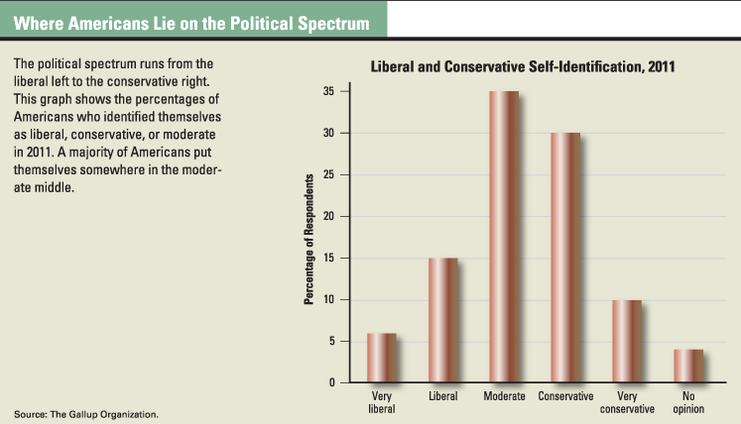
The Moderates in the Middle: Centrism
Most Americans don’t fit neatly into any ideological camp. They consider themselves moderates, or middle-of-the-road voters. These are people who sit at the center of the political spectrum, between the ideologies of left and right. In recent years, U.S. politics have become more polarized, meaning that political parties have adopted more extreme policies. The Republican Party has grown more conservative, and the Democratic Party more liberal.

In contrast to people with a strong ideological point of view, centrists may hold a mix of liberal, conservative, and perhaps environmental views. Centrism is not an ideology with its own political party. As a result, during election time, centrists often cross party lines, depending on the candidates and issues of the day. Moderates are an essential group in democratic states; they often help to keep the extreme ends of the political spectrum in line, making sure one group doesn’t become too crazy or too out of control.

Source: TCI Government Alive!
U.S. Government Name:
Mrs. Barnes
Political Culture and Ideology

Liberal | Ideology | Conservative
 | Size of Government
 | What do they want the government to do?
 | Where are they on the political spectrum?
 | Party Affiliation

Political Spectrums:

