U.S. Government Name:
Mrs. Barnes
Organization of Congress
The framers of the Constitution viewed Congress as “the first branch of government.” In The Federalist No. 51, James Madison wrote, “In republican government, the legislative authority necessarily predominates,” meaning that the Legislative branch naturally outweighs the other two. That is why the Constitution spells out the Legislative Branch first, in Article I.

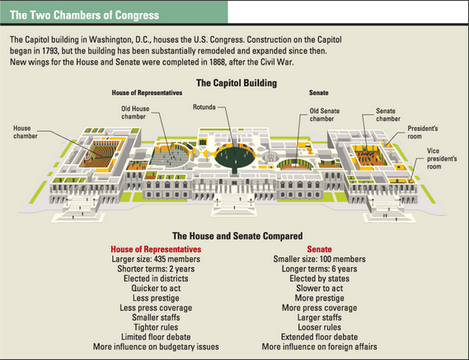
A Bicameral Legislature: The House and Senate
The Constitution establishes Congress as a bicameral legislature, consisting of the House of Representatives and the Senate. Although both chambers serve as lawmaking bodies, they are different in many respects. The lists at the bottom of this diagram highlight some of those differences. The framers expected the House, with its larger size and more frequent elections, to act as the “people’s body.” The Senate, whose members serve longer terms and were originally chosen by state legislatures, was meant to be a more elite chamber that would act as a steadying influence on Congress.

In 1913, with the ratification of the Seventeenth Amendment, the Senate became elected directly by voters instead of by state legislatures. Today, the two houses of Congress are equal in power.

Leadership Roles in the House
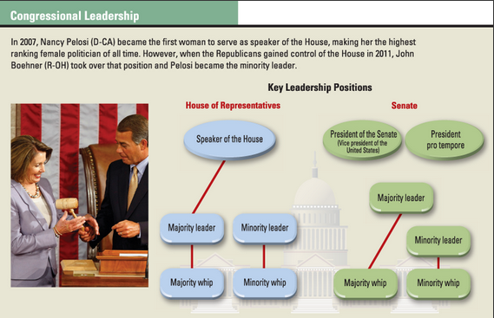
Since the mid-1800s, Congress has based its organization on the two major political parties. In each house, the majority party—the one with the most seats—controls the agenda. The minority party serves as a counter to the majority. The three leadership roles in the House are: the speaker, the majority and minority leaders, and the whips.

- Speaker of the House. The House speaker has more power and prestige than any other leader in Congress. The speaker is nominated by the majority party but wins the position through a vote of the entire House. The speaker presides over the House, assigns bills to committees, and appoints members to committees.
- Majority and minority leaders. In the House, the majority and minority leaders are elected by their respective parties. Their duty is to manage legislation on the House floor, (where members debate and vote on bills).
- Majority and minority whips. These assistant floor leaders are responsible for keeping the leadership informed and persuading party members to vote along party lines. The term whip was first used in the British Parliament. In England, a whip is the person who keeps the dogs under control during a fox hunt.

Leadership Roles in the Senate
The leadership positions in the Senate are the president, majority and minority leaders, and whips.
- President of the Senate. The president of the Senate is the official presiding officer of this body. The Constitution assigns this position to the vice president of the United States. In general, however, the vice president appears on the Senate floor only for ceremonies or to break a tie vote.
- President of the Senate pro tempore. The president of the Senate pro tempore is the senior senator of the majority party and runs sessions when the vice president is not there. The term pro tempore means “for the time being.”
- Majority leader. The majority leader serves as the spokesperson for the party that holds the most seats in the Senate. The Senate majority leader must work with party members and the minority leader to move legislation to a vote.
- Minority leader. This leader helps shape minority party policy and works to oppose majority party policies. The minority leader also works with the Senate majority leader to schedule business on the Senate floor.
- Majority and minority whips. The main duty of these assistant floor leaders is to stand in for the majority and minority leaders. Their other duties vary, depending on the needs of their party leaders.
Source: TCI Government Alive!

Questions:
- Compare the House and Senate:
Characteristic | House of Representatives | Senate
Size
(# of members)
Terms
(# of years)
3 Facts/Aspects
3 Requirements to be a Member (look up in U.S. Constitution)
Who serves as the leader?

- What is the primary purpose of the “whips”?

