U.S. Government Name:
Mrs. Barnes
On Government: Hobbes, Locke, Montesquieu, and Rousseau

Philosopher: | Questions: | Main Idea:
Hobbes:  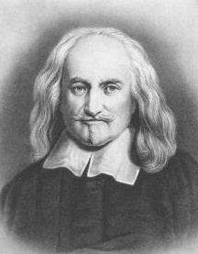 | - What did Hobbes write? What was it about?  - What is a leviathan?  - What is “state of nature”?  - What is the effect of state of nature?  - According to Hobbes, who should rule?  - What is the social contract? How does it work?
Locke:  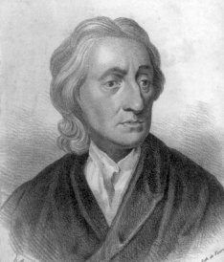 | - What did Locke write? What was it about?  - On which two major points did Locke and Hobbes disagree?  - According to Locke, what are natural rights?  - According to Locke, what happened when a sovereign violated the natural rights of the people?  - Which form of government did Locke prefer?  - Who would have supreme authority in Locke’s ideal form of government?
Philosopher: | Questions: | Main Idea:
Montesquieu:  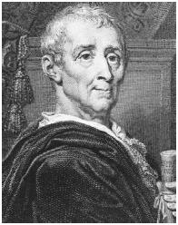 | - What did Montesquieu write?  - How did Montesquieu feel about the state of nature?  - What did war among individuals lead to?  - What is the main purpose of government according to Montesquieu?  - According to Montesquieu, how should power be separated?
Rousseau:  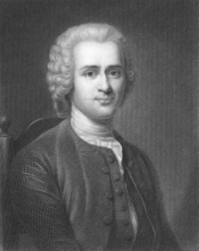 | - How did Rousseau view man?  - How did Rousseau view state of nature?  - How did Rousseau view the social contract?  - According to Rousseau, what is a “civil state”?  - In your own words, explain Rousseau’s ideal form of government.

