U.S. Government Name:
Mrs. Barnes
Federalism—Benefits and Drawbacks

The Tenth Amendment clarifies the constitutional division of powers by declaring that powers not specifically delegated to the national government are reserved for the states. These reserved powers include overseeing public schools, regulating businesses, and protecting state resources. The states also reserve the power to establish and regulate local governments.
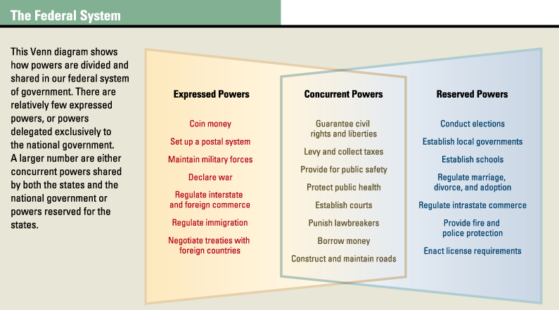

The Benefits of a Federal System
While the framers had little choice but to create a federal system of government, they could see several benefits of federalism. Four of the most important are listed below.

Federalism protects against tyranny of the majority. By dividing power among several units of government, federalism makes it difficult for a misguided majority to trample the rights of a minority. If a minority group feels abused in one state, its members can move to a state where their rights are more likely to be respected.
Jonah Goldberg, an editor with the National Review, compared the states to housing dorms on a hypothetical college campus to describe how this protection benefits a diverse population. On this campus, roughly half of the students like to have loud parties every night, while the other half like to have peace and quiet for studying. He wrote,
A purely democratic system where all students get to decide dorm policy could result in the tyranny of 51 percent of the students over 49 percent of the students. The party-hardy crowd could pass a policy permitting loud music and . . . parties at all hours of the night. Or if the more academically rigorous coalition won, they could ban “fun” of any kind, ever . . . But, if you allowed each individual dorm to vote for its own policies, you could have a system where some dorms operate like scholarly monasteries and other dorms are more fun than a pool party . . . Theoretically, 100 percent of the students could live the way they want. Maximized human happiness!
—Jonah Goldberg, “United States of Happiness,” National Review Online, 2004
Federalism promotes unity without imposing uniformity. As Goldberg's example suggests, federalism allows groups with different values and different ways of life to live together in peace. Likewise, federalism allows states to pass laws that reflect the needs and goals of their citizens while still remaining part of the union of states. All states, for example, support public education for young people. But how schools are funded and regulated differs from state to state, depending on local preferences.

Federalism creates “laboratories” for policy experiments. The flexibility of federalism allows states to act as testing grounds for innovative solutions to common problems (THINK: Colorado and the legalization of marijuana). U.S. Supreme Court Justice Louis Brandeis once noted,
It is one of the happy incidents of the federal system that a single courageous State may, if its citizens choose, serve as a laboratory and try novel social and economic experiments without risk to the rest of the country.
—Justice Louis Brandeis, dissent in New State Ice Co. v. Liebermann, 1932

If a state tries a new idea and succeeds, other states will follow suit. On the other hand, if an experimental policy fails, the problems that result are limited to one state. In some cases, a failure may provide lessons to others about better ways to implement policies.

Federalism encourages political participation. Finally, federalism provides an opportunity for people to be involved in the political process closer to home than the nation's capital. As Goldberg observed,
The more you push . . . decisions down to the level where people actually have to live with their consequences, the more likely it is they [the people] will be a) involved and interested in the decision-making process, and b) happy with the result. Federalism . . . requires the consent of the governed at the most basic level. Sure, your side can lose an argument, but it's easier to change things locally than nationally.

The Drawbacks of a Federal System
For all of the benefits, there are drawbacks to a federal system. One is the lack of consistency of laws and policies from state to state. This can create problems when people move from state to state. Drivers who cross state lines, for example, may not be aware that the speed limits and traffic laws of one state may not apply to the next. Teachers and other professionals often face hurdles when they move from state to state. A teaching credential valid in one state may not allow a teacher to teach in another state without additional testing or coursework.

Another drawback of our federal system is the tension it sometimes creates between state and federal officials. The Constitution does not always draw a clear dividing line between national and state powers. For example, it does not specify whether control of wildlife should be a federal or a state responsibility. The same can be said for other issues, such as regulating air quality and providing health care to the poor. When questions arise over who is in charge, it is often left to the Supreme Court to draw the line between the state and federal authority.
Source: TCI Government Alive!
On a separate sheet of paper, create a T-chart (like the one below) and identify (list) all of the benefits and drawbacks to the federal system.
Benefits of Federalism | Drawbacks of Federalism

