U.S. Government Name:
Mrs. Barnes
Elements of the Constitution

Elements of the Constitution
The Constitution provides the basic framework for American government. It also guarantees the rights and freedoms that we, as Americans, sometimes take for granted. Certain cases help to clarify those rights. The Constitution is a three-part document, consisting of the Preamble, the articles, and the amendments. Although it may seem complicated, the Constitution is actually a relatively brief and straightforward document.

The Preamble Sets the Purpose
The opening paragraph, the Preamble, is a single, long sentence that defines the broad purposes of the republican government created by the Constitution. It begins with the phrase “We the people,” signifying that power and authority in our system of government come from the people, not the states. The Preamble goes on to set various goals for the nation under the Constitution. These goals are expressed in a series of key phrases.
1.)Form a more perfect union. The framers of the Constitution wanted to ensure cooperation among the states, and between the states and the national government. 2.) Establish justice. The framers hoped to create a system of government based on fair laws that apply equally to all people. 3.) Ensure domestic tranquility. The framers wanted government to ensure peace and order. 4.) Provide for the common defense. The framers wanted the government to protect the nation against foreign enemies. 5.)Promote the general welfare. The framers hoped the government would ensure the well-being of the citizens. 6.) Secure the blessings of liberty to ourselves and our posterity. The framers hoped to guarantee freedom for Americans, then and in the future.

The Articles Establish Our National Government
The main body of the Constitution consists of seven articles. These seven articles are further divided into sections and clauses. The first three articles establish the three branches of government—legislative, executive, and judicial—and define their powers. These articles lay out the basic structure of the national government.
The four remaining articles of the Constitution cover various subjects, including relations among the states, the supremacy of national law, and the amendment process.

Article I Establishes the Legislative Branch
The first article sets up Congress as the lawmaking body in government. It describes the two chambers of Congress, the Senate and the House of Representatives, as well as the election, terms, and qualifications of their members. It also sets guidelines for rules and procedures in each chamber. This is the longest article in the Constitution, reflecting the founders' belief in the importance of the legislature in a representative democracy.

Section 8 of Article I lays out some of the main powers granted to Congress. These powers are both enumerated and implied. Enumerated powers are those that are specifically listed in the Constitution, such as the power to collect taxes, coin money, and declare war.

Implied powers are those that the legislature can claim as part of its lawmaking responsibility. This claim to implied power stems from Clause 18 of Section 8, which says that Congress can "make all laws which shall be necessary and proper" for carrying out its duties. This Necessary and Proper Clause is also known as the Elastic Clause, since it can be "stretched" to cover a variety of issues and circumstances.

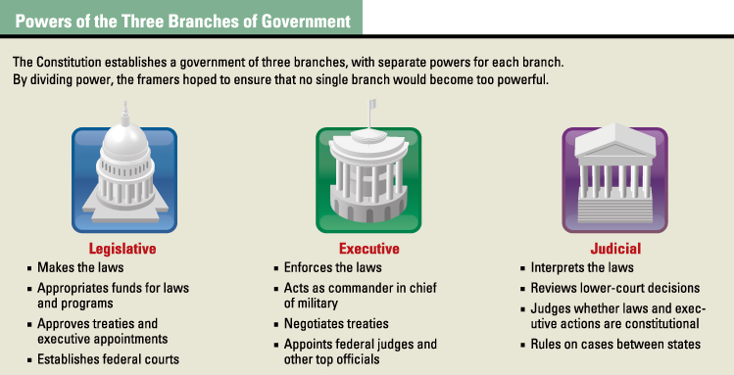
Section 9 of Article I lists powers denied to Congress. Among these denied powers are the suspension of habeas corpus and the granting of titles of nobility. Habeas corpus is the right of accused persons to be brought before a judge to hear the charges against them.

Article II Establishes the Executive Branch
The executive branch is led by the president and vice president. Article II of the Constitution describes the election, terms of office, and qualifications of these executive officers. It also defines the powers of the president, which include the power to command the armed forces, to make treaties, and to appoint other executive officials.

Article III Establishes the Judicial Branch
Article III creates the Supreme Court, the highest court in the land, while leaving Congress to create the lower courts. It defines the jurisdiction of the federal courts, specifying the types of cases that can be tried. It also guarantees the right to trial by jury in criminal cases and defines the crime of treason.

Article IV Concerns Relations Among the States
Article IV has four sections, which make the following key points:
1.) Full faith and credit 2.)Treatment of citizens 3.)New states and territories 4.)Protection of states

Article V Describes the Amendment Process
The framers understood that it might be necessary to make changes to the Constitution from time to time. Article V spells out the ways such amendments can be proposed and ratified.

Article VI Makes the Constitution the Supreme Law of the Land
Article VI covers several topics. It states that the national government agrees to repay all of the debts that were incurred under the Articles of Confederation. This was critical to ensure support for the new government.

It also states that the Constitution is the "supreme Law of the Land." This section, known as the Supremacy Clause, means that federal law supersedes all state and local laws. When the laws conflict, federal law reigns supreme.
In addition, it stipulates that all federal and state officials must take an oath swearing their allegiance to the Constitution. Also, no religious standard can be imposed on any official as a qualification for holding office.

Article VII Explains the Ratification Process
Article VII stipulates that the Constitution would not take effect until ratified by at least nine states. Although the Constitution was signed by the framers on September 17, 1787, ratification did not occur until the following year.

U.S. Government Name:
Mrs. Barnes
Elements of the Constitution

- Copy down the Preamble to the Constitution (live it, learn it, love it).

- Fill out the chart below:
Section of the Constitution | Main Subject, Structure, or Power Addressed in the Section
Preamble
Article I
Article II
Article III
Article IV
Article V
Article VI
Article VII

- Define:
  - Enumerated Powers:

  - Implied Powers:

  - Necessary and Proper Clause:

  - Elastic Clause:

  - Habeas Corpus:

- Where can the Supremacy Clause be found in the Constitution? What does it mean?

